Multiple-choice section – choose the correct answer

Question 1 [9.1]

Which of the following is *not* a quadratic equation?

**A** *y* = 5 – 2*x*2 + 8 **B** *y* = -8*x*3 + 12*x* – 1 **C** *y* = *x*2 + 5*x* – 32 **D** *y* = -3*x*2 + 3*x* + 6

Question 2 [9.3]

To obtain the graph of *y* = (*x +* 4)2 + 2 we translate the graph *y* = *x*2:

**A** 4 units left and 2 units up

**B** 4 units right and 2 units up

**C** 4 units left and 2 units down

**D** 4 units left and 2 units down

Question 3 [9.5]

The graph below is an example of:

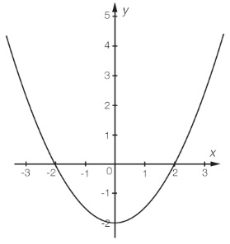

**A** an exponential **B** a parabola **C** acircle **D** a hyperbola

Question 4 [9.3]

The dilation factor for *y* = 3*x*2 + 4 is:

**A** 2 **B** 3 **C** 4 **D**  

Question 5 [9.4]

Which of the following equations would graph as a circle?

**A** *x*2 + *y*2 = 4 **B** *x*2 + *y* = 9 **C** *x* + *y*2 = 16 **D** *xy* = 81

Question 6 [9.2]

The solution to *x*(*x* – 9) = 0 is:

**A** *x* = 9 **B** *x* = 0 or -9 **C** *x* = 0 or 9 **D**  *x* = -9 or 9

Question 7 [9.7]

Find the equation for the following table of values:

|  |  |  |  |  |
| --- | --- | --- | --- | --- |
| *x* | 8 | 16 | 24 | 48 |
| *y* | 6 | 3 | 2 | 1 |

**A**  *y* =  **B**  *y* =  **C**  *y* = 48*x* **D** *yx*2 = 48

Question 8 [9.4]

What is the centre and radius of the circle with the equation *x*2 + (*y +* 8)2 = 100?

**A** (0, -8), 100 **B** (0, 8), 100 **C** (0, -8),10 **D** (0, 8),10

Question 9 [9.5]

Which equation will not graph a hyperbola?

**A** *y* =  – 2 **B** *y* = 3 –  **C** *y* =  + 6 **D** *xy* = 5

Question 10 [9.6]

*a* is directly proportional to the square root of *b.* The equation can we written as:

**A** *a* = *kb2***B** *a* = *kb*  **C** *a* = **D** *a* = *k*

Multiple-choice results: ___ / 10

Short answer section

Question 11 4 marks [9.1]

The following graph has the equation *y* = *x*2 + 2*x* – 8. State:

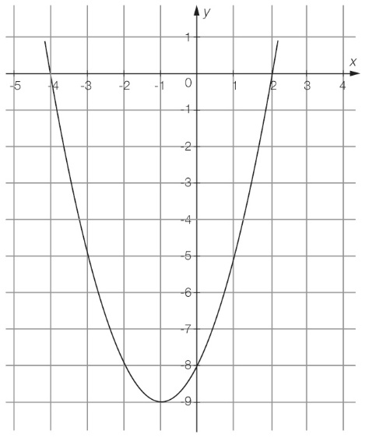

**(a)** the coordinates of the turning point

**(b)** the *x*-intercepts

**(c)** the *y*-intercept

**(d)** the equation of the axis of symmetry.

Question 12 8 marks [9.1]

For the equation *y* = *x*2 + 8*x* + 16:

**(a)** complete the table of values

|  |  |  |  |  |  |  |  |  |  |
| --- | --- | --- | --- | --- | --- | --- | --- | --- | --- |
| *x* | -8 | -7 | -6 | -5 | - 4 | -3 | -2 | -1 | 0 |
| *y* |  |  |  |  |  |  |  |  |  |

**(b)** plot the points on a Cartesian plane and join with a smooth curve

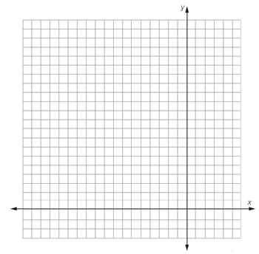

**(c)** write the coordinates of the turning point.

**(d)** state the nature of the turning point.

Question 13 3 marks [9.2]

Solve the following equations using the null factor law.

**(a)** (*x* + 9)(*x* – 3) = 0

**(b)** *x*2 + 4*x* = 0

**(c)** *x*2 – 81 = 0

Question 14 4 marks [9.2]

Solve the following equations using the null factor law.

**(a)** *x*2 + 12*x* + 35 = 0

**(b)** *x*2 = 7*n* + 18

Question 15 2 marks [9.2]

Use the null factor law to determine the *x*-intercepts for the graph of *y* = 3*x*2 + 17*x* + 10.

Question 16 6 marks [9.3]

State the transformations that should be made to the graph of *y* = *x*2 to obtain the graph of each of the following.

|  |  |  |  |  |  |
| --- | --- | --- | --- | --- | --- |
|  | Equation | Dilation  factor | Reflection in *x*-axis | Translation in *x*-direction | Translation in *y*-direction |
| **(a)** | *y* = *x*2 + 6 |  |  |  |  |
| **(b)** | *y* = 8(*x* – 8)2 – 8 |  |  |  |  |
| **(c)** | *y* = -4(*x* + 3)2 – 2 |  |  |  |  |

Question 17 2 marks [9.3]

Find the new equation when the following transformations are performed on the graph *y* = *x*2.

**(a)** The graph is dilated by a factor of 6, translated 2 units to the left and 4 units up

**(b)** The graph is dilated by a factor of , translated down 3 units and to the right 5 units.

Question 18 3 marks [9.4]

Determine the centre and radius of the following circle algebraically and hence the equation of the circle.

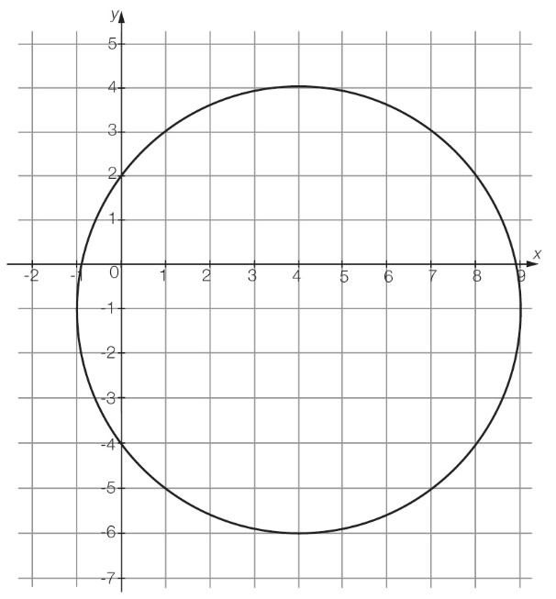

Question 19 1 marks [9.4]

A circle has the equation (*x* – 4)2 + (*y* – 2)2 = 25. What would the equation of this circle be if it is translated 2 units right and 3 units down and the radius is increased by 1 unit?

Question 20 4 marks [9.5]

Consider the following graph:

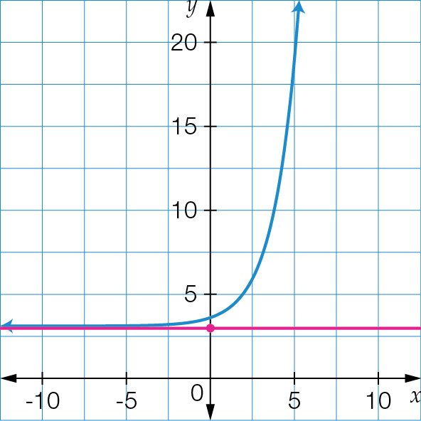

**(a)** What type of relationship does this graph represent?

**(b)** What is the value of the *y*-intercept for this graph?

**(c)** What is the name of the horizontal line passing through *y* = 3?

**(d)** What is the function of the line in **(c)**?

Question 21 5 marks [9.6]

Consider the following table.

|  |  |  |  |  |
| --- | --- | --- | --- | --- |
| *x* | 1 | 3 | 5 |  |
| *y* | 5 |  | 25 | 40 |

**(a)** Circle the correct description of the relationship between *x* and *y*. Give reasons for your answer.

*y* is directly proportional to *x* OR *y* is inversely proportional to *x*

**(b)** Find the constant of proportionality *k* for this relationship.

**(c)** Use your value for *k* to find the missing values in the table.

Short answer results: ___ / 42

Extended answer section

Question 22 8 marks [9.1]

A ball that is thrown. It follows a parabolic path whereby its height above the ground (*h* metres) at any time (*t* seconds) is given by the relationship *h* = -5*t*2 + 25*t*.

**(a)** Complete the table of values for this relationship.

|  |  |  |  |  |  |  |
| --- | --- | --- | --- | --- | --- | --- |
| *t* | 0 | 1 | 2 | 3 | 4 | 5 |
| *h* |  |  |  |  |  |  |

**(b)** Plot the graph of this relationship clearly showing:

**(i)** the turning point **(ii)** *x*-intercepts **(iii)** *y*-intercept.

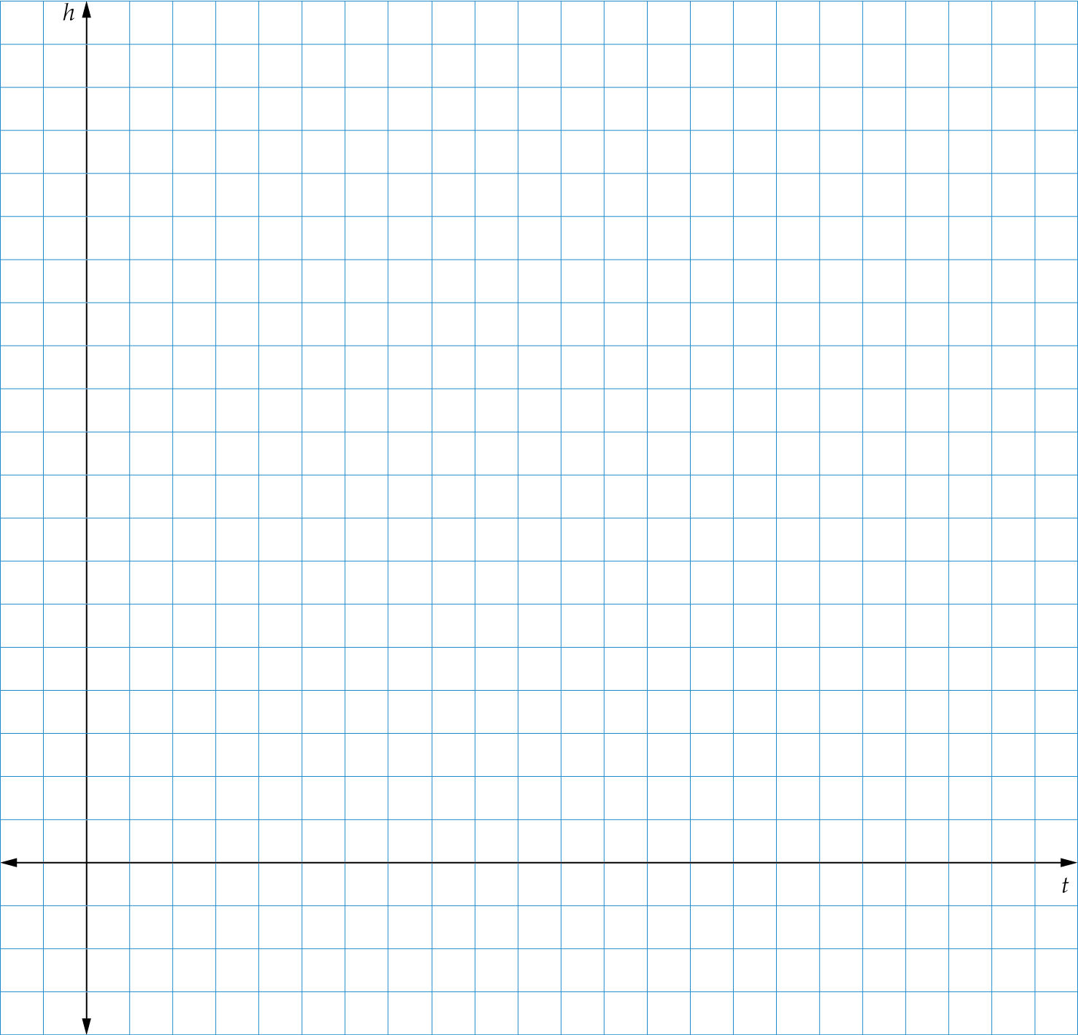

**(c)** What is the maximum height of the ball?

**(d)** At what time does the ball reach its maximum height?

**(e)** When does the ball hit the ground?

**(f)** When was the ball 20 metres from the ground?

Question 23 8 marks [9.4]

A kite is inscribed inside a circle with vertices *A*(9, 5), *B*(5, 1), *C*(13, 1) and *D*(9, -3). The vertices of the kite lie on the circumference of the circle.

**(a)** Draw a diagram of the circle and kite, shading the kite.

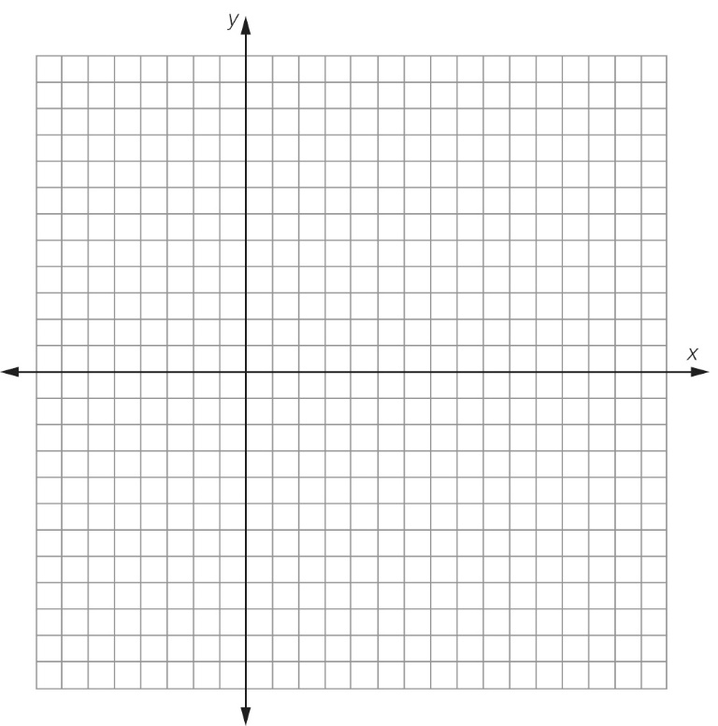

**(b)** What is the equation of the circle?

**(c)** If the kite represents a concreted area and the surrounding parts of the circle represent a garden bed, what is the area of the garden bed? State your answer correct to 3 decimal places.

Question 24 6 marks [9.5]

**(a)** A rectangular hyperbola has asymptotes at *x* = -1 and *y* = -3. Assuming *a* = 1, determine the equation of the graph.

**(b)** What is the value of the *x*-intercept of the hyperbola?

**(c)** What is the value of the *y*-intercept of the hyperbola?

**(d)** Provide a sketch of your equation in **(a),** clearly showing all key features.

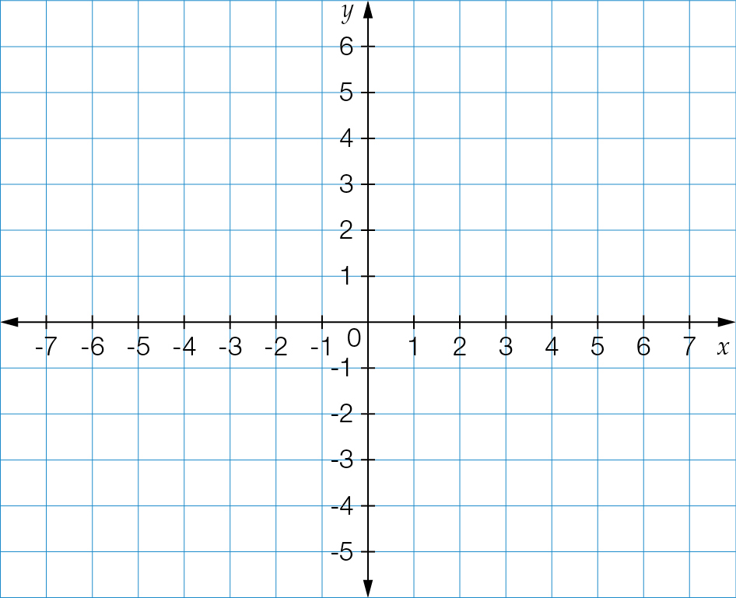

Question 25 8 marks [9.5] [9.6] [9.7]

The pressure of an amount of gas inside a scuba diving tank decreases as the volume of the tank increases.

**(a)** Is this relationship an example of direct or inverse proportion? Explain your answer.

**(b)** The pressure of the air inside a tank with a volume of 20 L is 400 kPa. Using your answer above, find the constant of proportionality.

**(c)** Determine the equation for this relationship.

**(d)** Complete the table.

|  |  |  |  |  |
| --- | --- | --- | --- | --- |
| Volume (*V*) | 2 | 4 | 8 | 10 |
| Pressure (*P*) | 4000 | 2000 |  |  |

**(e)** Plot the graph of volume against pressure.

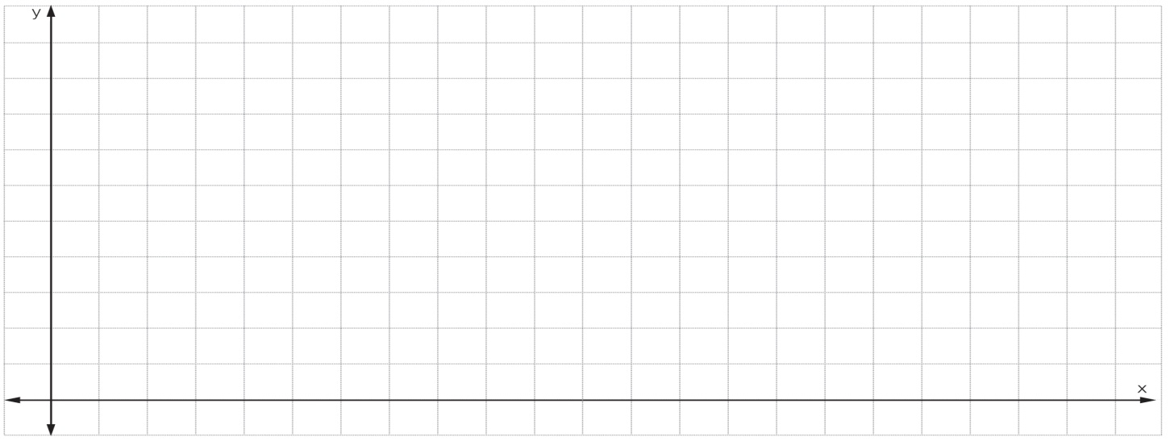

**(f)** How does the shape of your graph confirm your answer in **(a)** above?

**(g)** When the pressure is 2000 kPa, what is the volume?

Extended answer results: ___ / 22

TOTAL test results: ___ / 64